**What determines the length of killing career of serial killers**

**Yumeng Li**

**Abstract**The length of killing career is the time interval between the first kill and last kill, it reveals serial killers’ psychology pattern. Radford/FGCU Serial Killer Database Project is used in this paper and observations are 424 serial killers who kill only for enjoyment. This study examines what can affect the length of killing career. The independent variables are divided into two groups, one describes how strong is the killer’s killing lust, the other describes how stable is the killer’s “normal” life. Using OLS, numbers of victims, race, previous jail experience, age when first kill, numbers of children and marital status can affect the length. Specially, I found when the age killer commits the first kill is young and old, length of killing career would be longer than middle age. But gender and work in law enforcement are not significant in this regression.

**1. Introduction**

**1.1Justification**  
Cooling off period is time interval between each killing, which is an important factor to analyze serial killers’ psychology. It shows the change of psychology as time goes by. When the killer is within a cooling off period, he/she will stop killing people and go back to his/her “normal" life. After cooling off period, the lust of killing overwhelms, the killer will start killing again. [1] I choose the length of killing career as my dependent variable which is the closest thing to cooling off period that I can find in this data set. The length of killing career is the time interval between the first kill and last kill. Normally, after the last kill, the killer would be arrested. This time interval can show the killer’s psychology and killing lust, in some extent, it can reveal cooling-off period.

**1.2 Theoretical framework**

There are few researches of serial killers using data analysis because serial killers are minority of people, which has a small sample. In this research, I will use OLS to examine what factors can affect this time interval, hope I could find a reasonable explanation to this question.  
There are many things that can the length of killing career. There is a variable named “Aamodt Type” in the data set, which contains 11 types of purpose about why the killer kills. In this study, I examine serial killers whose killing purpose is only enjoyment. Because if killers from this group will have a stronger killing lust than killers who kill for finance purpose. I assume the results are more obvious among this group. After reading these articles, I find that I can divide these determines into two groups. One is to describe how strong is the killing lust of the killer. The other is to describe whether the killer has a stable life besides killing. The first one is easy to understand, if the killer has a very strong lust of killing, his/her time interval would be shorter. For the second one, if a killer has a “normal” life, for example, marriage or have kids, he/she needs to be caution during the time interval, they want to keep this life in order to disguise or enjoy normal life.   
I use the length of killing career as my dependent variable, examine the relationship between this time interval and selected variables. If a variable is significant, I can say it affects the time interval based on this data set. I couldn’t find accessible literature related to this question. Few people would use data to analyze it. But from articles I find, kill patterns differs from male and female[2] . Also, there is a study [3] shows that the average male serial killer has a "career" span of 2-3 years, with female serial killers lasting almost 11 years. So, I include gender in my regression. One studies if there is difference in the time frame for murder among three groups which are male, female and partner[4]. At first, I also want to divide the samples as three group, but the killers without partners is 85% in the data set, few has partners, so I did not divide the samples like the literature did.

**2. Data**  
**2.1 Data set**

I got the data set from Radford/FGCU Serial Killer Database Project [5]. The data set is called Serial Killer data base- student version ,2019.Although I don’t think this data set contains all of serial killers, the database is still the largest non-governmental serial murderer database in the world. It contains 117 variables and 5178 serial killers in the world. Since serial killers are minority of people, I don’t think there is selection bias in this sample.  
**2.2 Descriptive statistics**

|  |  |  |  |  |  |  |
| --- | --- | --- | --- | --- | --- | --- |
| **Variable** | **Description** | **N** | **Mean** | **Std Dev** | **Minimum** | **Maximum** |
| Age1stKill | Age at first kill in series | 424 | 28.785 | 9.387 | 8 | 60 |
| Male | Sex of the killer Gender 1=male 0=female | 424 | 0.955 | 0.207 | 0 | 1 |
| Black | Race | 424 | 0.314 | 0.342 | 0 | 1 |
| Num Vics | Numbers of victims | 424 | 8.182 | 16.215 | 2 | 215 |
| MS | Marital Status  1=Married & engaged  0= Single, Separated, Divorced & Widowed | 424 | 0.354 | 0.479 | 0 | 1 |
| Number of Children | Numbers of Children | 424 | 1.158 | 1.629 | 0 | 9 |
| Length | Year of final kill-Year of first kill | 424 | 4.922 | 6.375 | 0 | 34 |
| WC | Worked in law enforcement? 0=No 1=Police ,Correction ,Security guard & Military police | 424 | 0.021 | 0.144 | 0 | 1 |
| Previous jail | Whether the killer went to the jail before killing Previous jail=1, Yes, Previous jail=0, No | 424 | 0.702 | 0.458 | 0 | 1 |

**2.3 Drop observations**  
The number of observations I use in the regression is 424, and the number of observations in the initial data set is 5178. I use “Filter” tool in Excel to drop observations which have no data in the variables I concerned. Race has 40 missing variables, Numvics has 59, Age when 1st kill has 419 year when first kill has 147, year when last kill has 85, WC has 85, MS has 2604, Number of children has 3779 and previous jail has 2790.  
**3. Methodology**  
**3.1 Theoretical relationship $${cooloff}_{i}=β_{0}+β_{1}Male_{i}+β_{2}Black_{i}+β_{3}WC_{i}+β_{4}NumVics_{i}+β_{5}NumberofChildren_{i}+β_{6}MS_{i}$$ $$+β_{7}Previousjail_{i}+β_{8}Age1stKill_{i}+β_{9}{Age}_{i}^{2}+ε_{i}$$**

**3.2 Describe variables**I divide the variables into two groups. One is called lust, which measures lust of killing. The other is called stable, which describes whether the killer has a stable life besides killing.

**3.2.1 Lust  
Male:** Describe the gender of the killer. If the killer is male, then Male=1, if the killer is female, then Male=0. The functional form of this variable is linear. I expect the sign of Male to be negative. Because there is study[6] shows that victims of male killers are mostly strangers, while victims of female killers are mostly not. From this study, I reason that male serial killers may have stronger killing lust.

**NumVics:** Describe the numbers of victims of each killer. I expect the sign to be positive. Normally, frequency of committing crimes could not be too high. If so, the killer would be arrested in a short time. It is reasonable that if the killer wants to kill more people, he/she will need more time. So, I use linear here as well.

**Black:** Describe the race of the killer. If the killer is black, then Black=1, else if the killer is not black, then Black=0. There is evidence[7] shows that crime rate among black people is higher than others. However, this may not be the case here. I want to use this regression to examine if situation similar in serial killers. I expect the sign to be negative and I use linear functional form here.

**WC:** Describe whether the killer works in law enforcement. If the killer works in law enforcement, WC=1, otherwise, WC=0. I use linear form here and I expect the sign to be positive. Working in law enforcement shows that the killer is more likely to have anti-investigation consciousness, which means using the methods that has confusing and destructive character to prevent the police from probing because they know how police investigation works, and they can hide themselves better. That will make his/her time interval become longer.

**Previous jail:** Describe whether the killer went to the jail before killing. It is a dummy variable. I use linear form here. Matt Delisi and Aaron M. Scherer[8] found that 40% of multiple homicide offenders have zero prior arrests. I don’t know for sure what is the expected sign of this variable.

**Age1stKill:** Describe age when the killer kills people for the first time. I use quadratic function here. Because in this data set, age difference from 8 to 60. I think younger and older killers may have different results from middle age killers. For younger and older killers, time interval between first kill and last kill may be longer. If a killer commit first crime in a young age, he /she is more likely to receive behavior modification, which will prolong the time interval. If a killer commit first killing in an old age, his/her physical strength and energy drop a lot, the frequency of killing may also drop. I expect this variable to be negative.

**Age2:** It is the square of Age1stKill. I expect this variable to be positive.

**3.2.2Stable  
Number of Children:** Describe how many children does the killer have. If the killer has more children, he/she is more likely to hide the lust of killing, the frequency of committing crime is lower than others. Every serial killer would experience a time interval when the killer chooses to stop committing crime and go back to normal life before the lust of killing finally overwhelms. For killers who have children, this time interval may be longer than others, which will make the time between first kill and last kill longer. I expect the sign to be positive and I use linear here.

**MS:** Describe marital status of the killer. Same as “Number of Children”, only that I create dummy variable for marital status. If the killer is married or engaged with someone, I code it as 1, otherwise, I code it as 0. I expect the sign is positive and I use linear here.

**4. Result**   
**4.1 Initial regression results**

|  |  |
| --- | --- |
| Variable | Initial Regression |
| Male | 2.569  (2.305) |
| NumVics | 0.081***  (0.024) |
| EduYrs | 0.176  (0.148) |
| Age1stKill | -0.195***  (0.045) |
| Number of Children | 1.056***  (0.306) |
| MS | 0.596  (0.979) |
| Adjusted R-squared =0.1733  F-value=8.16(Pr>F:<0.0001) |  |

***p<0.01

**p<0.05

*p<0.1

I don’t expect the sign of Age1stKill to be negative. I use linear function here, so I change the functional form of Age1stKill in the finial regression. Also, there are only 206 observations in the initial regression because for years of education, there are so many missing values, and years of education is not even significant, so I delete this variable in the final regression. There are only three variables that are significant, so I reconsider my independent variables in the final regression, I add race, work in low enforcement and previous jail experience.

**4.2 Final regression results**

|  |  |
| --- | --- |
| Variable | Final Regression |
| Male | 1.852  (1.434) |
| NumVics | 0.087***  (0.018) |
| Black | -3.045***  (0.848) |
| WC | 1.528  (2.006) |
| Previous jail | 1.380**  (0.655) |
| Age1stKill | -0.471***  (0.156) |
| Age2 | 0.005**  (0.002) |
| Number of Children | 0.469**  (0.207) |
| MS | 1.418**  (0.698) |
| Adjusted R-squared =0.1405  F-value=8.68 (Pr>F:<0.0001) |  |

***p<0.01

**p<0.05

*p<0.1  
**4.3 Interpretation**

**4.3.1 Adjusted R-squared**

14.05% of variation in length is explained by the regression, adjusted for degrees of freedom.

**4.3.2F-value**  
The null hypothesis is that all of the regression coefficients for the full model are zero. The probability for the null hypothesis is true is less than 0.01%. I can reject the null hypothesis on the F-test.

**4.3.3 Beta coefficient & t-test**

**Male:** Probability with this t-value is 0.1972, I can’t reject the null hypothesis on this t-test, which means that the gender of killers does not matter to length of killing career on this data set. The coefficient of male is not significant, I cannot interpret this coefficient. That is not the expected sign for this variable, the gender should matter because male killers and female killers have different killing patterns. I think the coefficient is not significant because there are only 19 female observations, 4.4% of all the observations.

**NumVics:** Probability with this t-value is less than 0.0001, I can reject the null hypothesis on this t-test, which means that the numbers of victims matter to length of killing career on this data set. The coefficient of NumVics is significant, it means as a killer’s the numbers of victims increases by one, the length of killing career increases by 0.087 years, holding other variables constant. That is consistent with my expected sign.

**Black:** Probability with this t-value is 0.0004, I can reject the null hypothesis on this t-test, which means that race of the killers matters to length of killing career on this data set. The coefficient of Black is significant, it means if the killer is black, the length of killing career decreases by 3.04 years, holding other variables constant. That is not the expected sign for this variable, I expect the sign to be positive. I think the sign is opposite because there are only 57 observations who is black, 13.4% of all the observations.

**WC:** Probability with this t-value is 0.45, I can’t reject the null hypothesis on this t-test, which means that whether the killer works in law enforcement does not matter to length of killing career on this data set. The coefficient of WC is not significant, I cannot interpret this coefficient. That is not the expected sign for this variable. I think the coefficient is not significant because there are only 9 female observations, 2.2% of all the observations.

**Previousjail:** Probability with this t-value is 0.036, I can reject the null hypothesis on this t-test at 10 percent level, which means that whether the killer has previous jail experience matters to length of killing career on this data set. The coefficient of Previousjail is significant, it means if the killer has previous jail experience, the length of killing career increases by 1.38 years, holding other variables constant. That is consistent with my expected sign.

**Age1stKill&Age2:** Probability with t-value of Age1stKill is 0.0027, probability with t-value of Age2 is 0.039, I can reject the null hypothesis on both t-test at 10 percent level, which means that the age when first kill matters to length of killing career on this data set. Both coefficients are significant. They mean if the killer’s age when first kill increase by one, the length of killing career will change (-0.47+0.005 *Age1stKill) years, holding other variables constant. That is consistent with my expected sign.

**NumberofChildren:** Probability with this t-value is 0.023, I can reject the null hypothesis on this t-test at 10 percent level, which means that the numbers of children matter to length of killing career on this data set. The coefficient of NumberofChildren is significant, it means as a killer’s the numbers of children increases by one, the length of killing career increases by 0.47 years, holding other variables constant. That is consistent with my expected sign.

**MS:** Probability with this t-value is 0.042, I can reject the null hypothesis on this t-test at 10 percent level, which means that the marital status matters to length of killing career on this data set. The coefficient of MS is significant, it means if the killer is married or engaged, the length of killing career increases by 1.42 years, holding other variables constant. That is consistent with my expected sign.

**4.4 Multicollinearity  
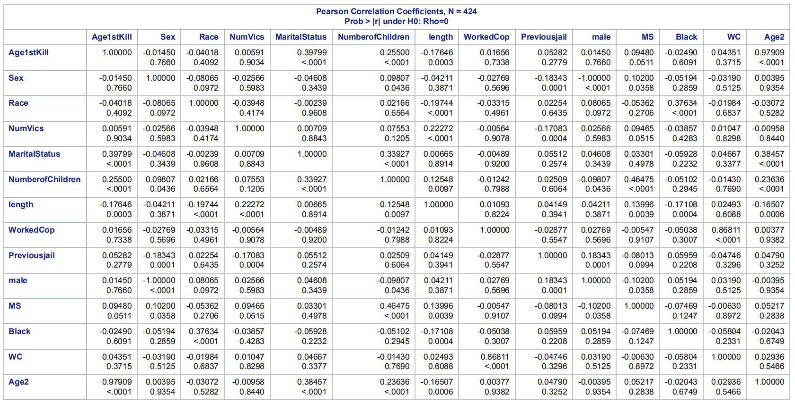**

Figure 1

Figure 1 is results from correlation. From this figure, I don’t suspect muticollinearity.

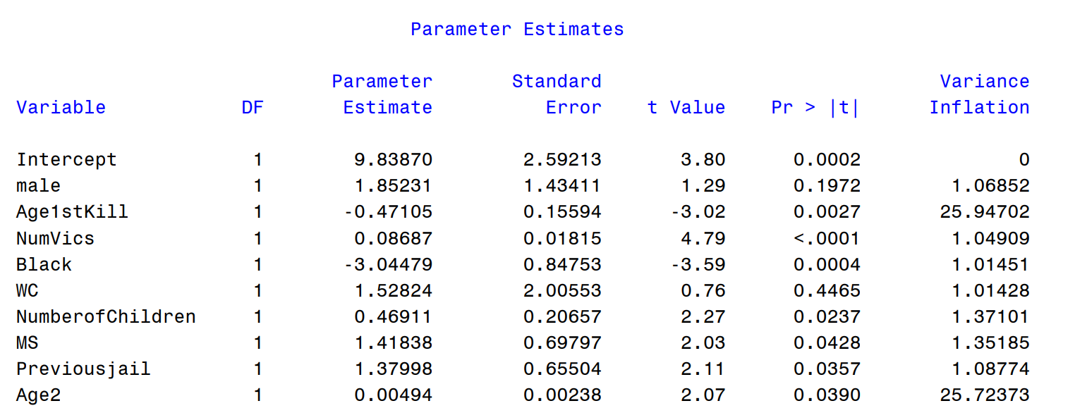  
Figure 2

I use SAS coding to examine if multicollinearity exists, the result is shown in Figure 2 above. From the result, none of the variables’ variance inflation are over 5, besides Age1stKill and Age2 because they have one to one relationship. I can say I don’t think multicollinearity exists.  
**4.5 Heteroscedasticity**

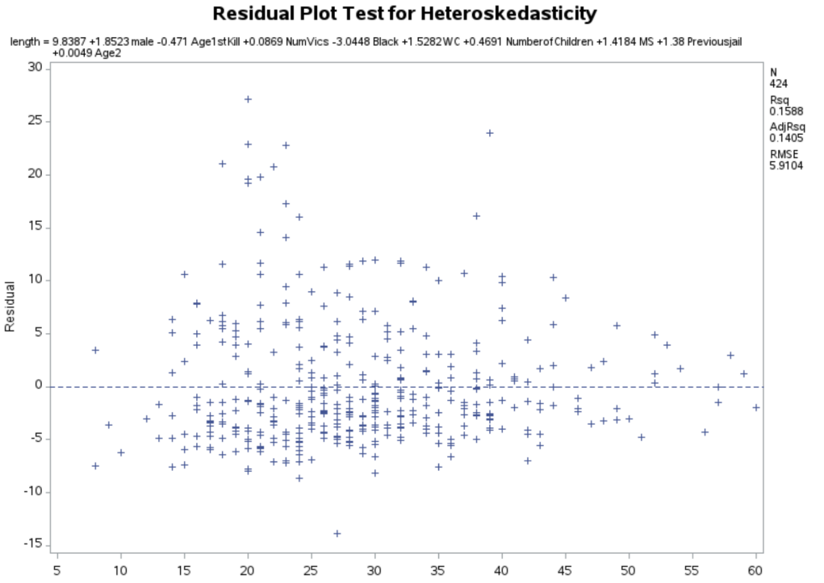

Figure 3

Figure 3 is the scatter plot for Age when 1st kill, this variable is what I think causing heteroskedasticity in my regression. I think the problem is the length of killing career is different with the age when 1st kill.

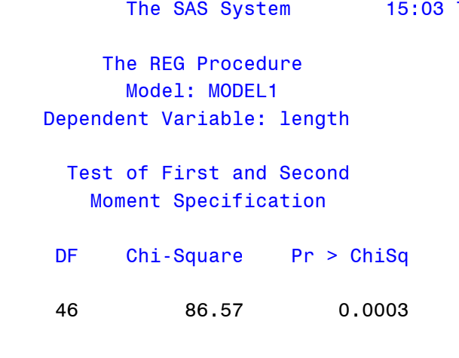

Figure 4

I use white test in SAS to examine heteroskedasticity, the result is shown in Figure 4 above. From the result, p-value of Chi-square is very low, I can reject the null hypothesis, which means heteroskedasticity exists.

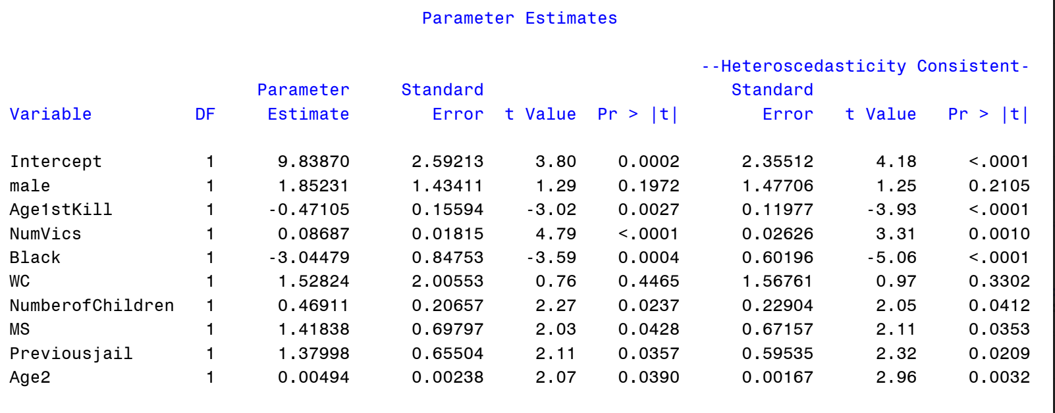  
Figure 5

From Figure 4, I can say the regression has heteroskedasticity, though white standard error is applied for regression with high degrees of freedom, but I want to use it to see if the regression changes a lot, the result is shown in Figure 5. From Figure 5, with adjusted standard error, male and WC still remain insignificant, all the other variables are significant, the regression doesn’t change. I think I have this problem because I have low degrees of freedom, I should not be concerned about it so much.

**5.Robustness Check**

|  |  |  |
| --- | --- | --- |
| Variable | Regression 1 | Regression 2 |
| Male | 1.582  (1.432) | -1.039  (0.822) |
| NumVics | 0.088***  (0.018) | 0.080***  (0.019) |
| Black | -3.146***  (0.849) | -2.611***  (0.658) |
| WC | 1.569  (2.008) | 1.437  (1.628) |
| Previous jail | 1.463**  (0.654) | 1.781***  (0.543) |
| Age1stKill | -0.499***  (0.157) | -0.518***  (0.112) |
| Age2 | 0.005**  (0.002) | 0.005***  (0.002) |
| Number of Children | --------  -------- | 0.379***  (0.142) |
| MS | 1.339*  (0.737) | 2.167***  (0.551) |
| Children | 1.444**  (0.715) | --------  -------- |
| Adjusted R-squared | 0.1383 | 0.1132 |
| F-value | 8.54 | 12.88 |

***p<0.01

**p<0.05

*p<0.1

For the first robustness check, I recode Number of Children, if the Number of Children is greater and equal to 1, Children=1, otherwise, Children=0. The regression result is shown in Regression 1. The result doesn’t change too much, just the coefficient of Children becomes bigger than coefficient of Number of Children in the final regression.

For the second robustness check, I use a bigger sample, the result is shown in Regression 2. For final regression, I use killers who only kill for enjoyment, and for this check, I eliminate that restriction. In the result, Male and WC are still insignificant, the t-value of others are all higher, they all become more significant. Though Male remains insignificant, the sign of the Male becomes negative, which is consistent with my expected sign. The unexpected sign of Male in the final regression has something to do with the small observations. If the sample become larger, Male may become significant.

**6. Conclusion and discussion**

The length of killing career is the time interval between the first kill and last kill, it reveals serial killers’ psychology pattern. This study uses data from Radford/FGCU Serial Killer Database Project, observations are 424 serial killers who kill only for enjoyment. This study examines what can affect the length of killing career. The independent variables are divided into two groups, one describes how strong is the killer’s killing lust, the other describes how stable is the killer’s “normal” life. Using OLS, numbers of victims, race, previous jail experience, age when first kill, numbers of children and marital status can affect the length. Specially, I use polynomial functional form in age when first kill, it turns out when the age is young and old, length of killing career would be longer than middle age. But gender and work in law enforcement are not significant in this regression.

This study suffers from several limitations. First is the size of the sample. For some variables, there are so many missing values, which reduces a lot of observations. Second is heteroskedasticity. I do not expect this happens, and due to small sample, I have no better solutions.

For future research, education level should be included in this regression, I exclude that because there are so many missing values, but I still think education level can affect length of killing career. Also, gender can be examined again if larger samples are found.

**7. Policy prescriptions**

Since age when first kill is not a linear functional form, people kill since young and old has a longer career span than middle. When people found a killer who is young, behavior modification should be received to prevent that happens in the future, especially to countries where young people don’t have to bear legal liability. For killers in middle age, people would experience the biggest pressure in life, a better way is to strengthen psychological counseling in the society, although psychological counseling may not be very efficient when it comes to serial killers, it still helps a little.

**Bibliography**

Benkart, Lizzie, "The Patterns of Women Serial Killers in a Climate of Changing Gender Norms" (2019). Sociology Senior Seminar Papers. 14.

Gurian, EA. 2017. "Reframing Serial Murder within Empirical Research: Offending and Adjudication Patterns of Male, Female, and Partnered Serial Killers." International Journal of Offender Therapy and Comparative Criminology 61 (5): 544-560.

Matt Delisi; Aaron M. Scherer, "Multiple Homicide Offenders: Offense Characteristics, Social Correlates, and Criminal Careers," Criminal Justice and Behavior 33, no. 3 (June 2006): 367-391

Penn state; psychology may help explain why male and female serial killers differ. 2019. *Psychology & Psychiatry Journal*, Apr 06, 2019.

Phillips, Julie A. “White, Black, and Latino Homicide Rates: Why the Difference?” Social Problems 49, no. 3 (2002): 349–73.

Radford/FGCU, Serial Killer Database Project

“Serial Killers ‘Cool Off’ Between Murders.” Psychology Today. Sussex Publishers. Accessed November 4, 2019.

“Serial Killers - What Age Do They (Usually) Start Killing?” Murder Mile Walks and True-Crime Podcast - one of the best "quirky, curious and unusual things to do in London" this weekend. Accessed November 20, 2019.

*“I have neither given or received, nor have I tolerated others’ use of unauthorized aid”*

*Yumeng Li*

1. “Serial Killers ‘Cool Off’ Between Murders.” Psychology Today. Sussex Publishers. Accessed November 4, 2019.  
   <https://www.psychologytoday.com/us/blog/wicked-deeds/201908/serial-killers-cool-between-murders.>
2. Benkart, Lizzie, "The Patterns of Women Serial Killers in a Climate of Changing Gender Norms" (2019). Sociology Senior Seminar Papers. 14. <https://creativematter.skidmore.edu/socio_stu_stu_schol/14>
3. “Serial Killers - What Age Do They (Usually) Start Killing?” Murder Mile Walks and True-Crime Podcast - one of the best "quirky, curious and unusual things to do in London" this weekend. Accessed November 20, 2019. <https://www.murdermiletours.com/blog/serial-killers-what-age-do-they-usually-start-killing>.
4. Gurian, EA. 2017. "Reframing Serial Murder within Empirical Research: Offending and Adjudication Patterns of Male, Female, and Partnered Serial Killers." International Journal of Offender Therapy and Comparative Criminology 61 (5): 544-560.
5. Radford/FGCU, Serial Killer Database Project, <http://skdb.fgcu.edu/info.asp>
6. Penn state; psychology may help explain why male and female serial killers differ. 2019. *Psychology & Psychiatry Journal*, Apr 06, 2019. https://ezproxy.valpo.edu/login?url=https://search.proquest.com/docview/2202589515?accountid=14811 (accessed November 13, 2019).
7. Phillips, Julie A. “White, Black, and Latino Homicide Rates: Why the Difference?” Social Problems 49, no. 3 (2002): 349–73. <https://doi.org/10.1525/sp.2002.49.3.349>.
8. Matt Delisi; Aaron M. Scherer, "Multiple Homicide Offenders: Offense Characteristics, Social Correlates, and Criminal Careers," Criminal Justice and Behavior 33, no. 3 (June 2006): 367-391